# What is gghalves?

gghalves is a new R package that makes it easy to compose your own half-plots using

ggplot2.

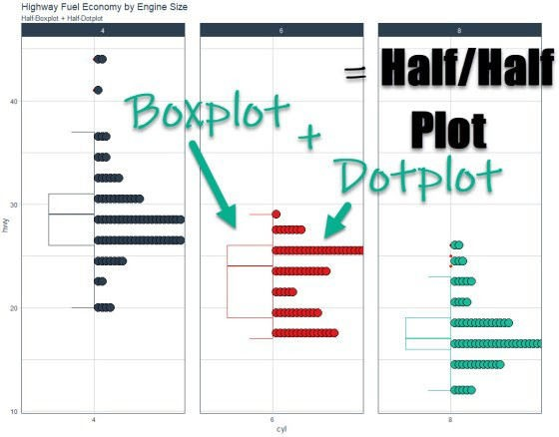

# gghalves Video Tutorial

## For those that prefer Full YouTube Video Tutorials.

Learn how to use gghalves in our free 8-minute YouTube video.

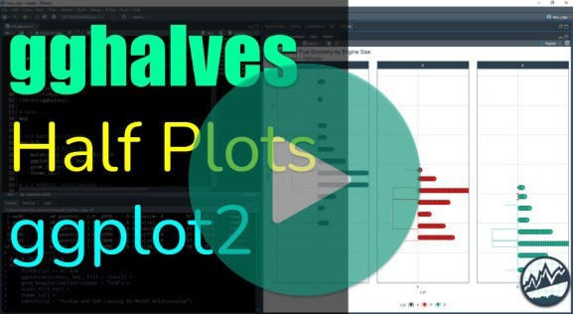

(Click image to play tutorial)

# What are Half Plots?

## Combining two plots side-by-side.



Half/Half Plots are a way to showcase two plots side-by-side. Here’s a common example:

1. Showing a **Boxplot** to identify outliers and quantiles
2. Showing a **Dotplot** to identify distribution

We can easily do this with a half-plot thanks to gghalves.

# Before we get started, get the R Cheat Sheet

gghalves is great for making customized ggplot2 plots. But, you’ll still need to learn how to wrangle data with dplyr and visualize data with ggplot2.

#### Quick Example:

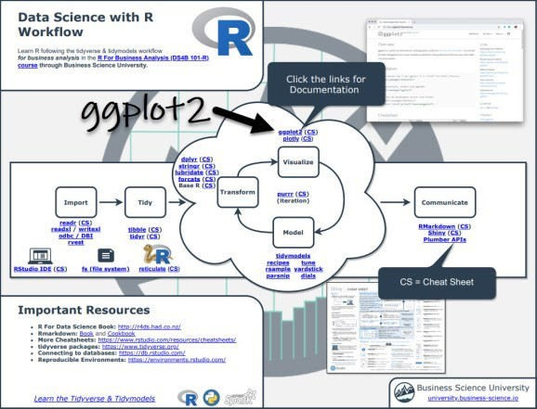

Now you’re ready to quickly reference ggplot2 functions. Onto the tutorial.

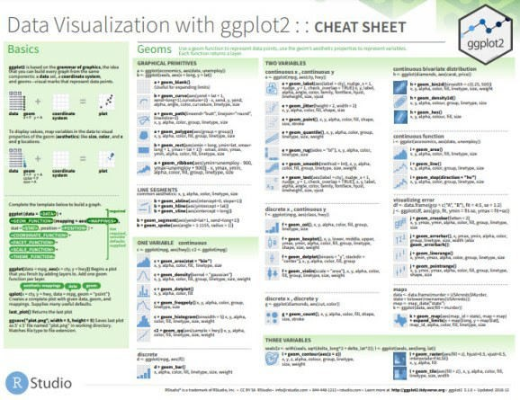

# How gghalves works

The gghalves package extends ggplot2 by adding several new “geoms” (ggplot geometries) that allow us to add half plots. In this tutorial, we’ll cover:

geom_half_boxplot(): For creating half-boxplots

geom_half_dotplot(): For creating half-dotplots

**Pro Tip:**

Simply type “geom_half” in your R console and hit Tab to show all of the half plotting geoms available.

### Load the Libraries and Data

First, run this code to:

1. **Load Libraries:** Load gghalves, tidyverse and tidyquant.
2. **Import Data:** We’re using the mpg dataset that comes with ggplot2.

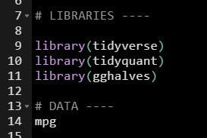

### Make the Half-Boxplot / Half-Dotplot

Next, we can combine a half-boxplot and half-dotplot. This has the advantage of showing:

**Quantiles and Outliers (Boxplot) Distribution (Dotplot)**

#### Business Goal

Suppose we have a question:

What effect does **Engine Size (number of Cylinders)** have on **Vehicle Highway Fuel Economy (Highway MPG)**?

We can visualize this with gghalves by making half-plots of Cylinder vs Highway.

#### Half-Plot Visualization Code

We’ll add geom_half_boxplot() and geom_half_dotplot() to make the half-plots of Cylinder vs Highway.

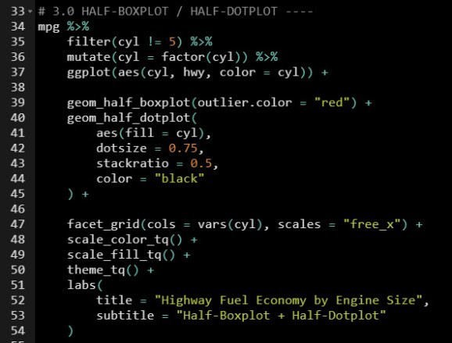

#### Half-Plot Visualization

Here is the visualization. We can explore to find an interesting relationship between Engine Size and Fuel Economy.

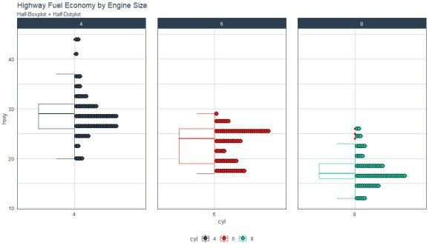

#### Insights: Bimodal Distribution of 6-Cylinder Engine Class

Generally speaking, fuel economy goes down as engine size increases. But, the 6-Cylinder engine has something unique going on that has been uncovered by the gghalves::geom_half_dotplot().

The 6-Cylinder Engine class of car has a **bimodal distribution**, which is when there are two peaks. This generally indicates that there are two different populations within the group. We need to investigate with ggplot2.

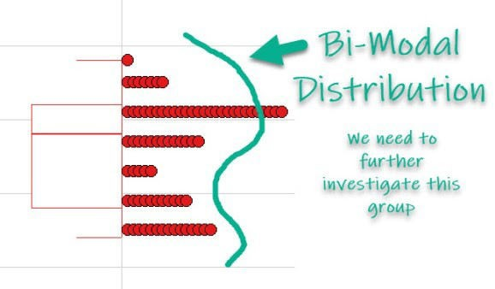

#### Exploring the Bimodal Relationship

We can explore the 6 Cylinder Vehicle Class a bit further to identify the cause of the Bimodal Distribution. It looks like:

**SUV and Pickup classes** have much lower fuel economy

**Compact, Midsize, Minivan, and Subcompact** have much higher fuel economy

